**EEE 320 INTRODUCTION TO INTERNET OF THINGS**

**FINAL EXAM PROJECT APPLICATION HOMEWORK (50P)**

Perform an IoT application (controlling over internet from web or Mobile app with Wifi) on an IoT cloud platform (chosen for final) for your IoT board (chosen for App-1,2,3), sensor (chosen for App-1) and wireless communication (chosen for App-2), in which you will determine the scope. A dc motor (Brushed, Step, or Servo) and one RGB (or at least three LEDs) should be used in your circuit.

**Purpose of Application:** You are free about the purpose of application. Clearly state the intended purpose in your video capture and in this document. BUT, at least you have to send the sensor data from your board to the Cloud interface (dashboard) and also control the circuit (e.g, LED/RGB or any element) from the Cloud interface.

**Circuit Diagram:** You are free to build your circuit for application. Draw your circuit in **Fritzing.**

**Restriction:** There is no restriction. You can use any IDE and programming language you want.

**Homework Submission:** Record a videowith all the team members for your application. In your video content; explain your program codes line by line, show your program to be compiled successfully, show your program to be uploaded to your board, show your circuit to be run successfully for each case.

The following files need to be uploaded to Teams.

1. This word document by completing the ANSWERS section (DO NOT upload as pdf)
2. Your video file (MUST be talked in English)
3. Fritzing circuit file
4. Application project folder created by IDE software. Include your source file

------------------------------------------------ANSWERS-----------------------------------------------

**Project Team** : Suat Deniz

**IoT Board Selected :** Raspberry Pi Pico W

**IoT Cloud Platform :** Google Firebase

**Sensor Selected :** MQ-5Gas sensor

**Wireless Communication Module Selected :** Infrared Module

**DC Motor Selected :** DC Stepper Motor 28BYJ-48

**Your Software IDE :** Thonny IDE

**Your Programming Language :** MicroPhython

**Application Purpose:**

**Overview**

The purpose of this project is to develop an integrated home automation and monitoring system using a Raspberry Pi Pico W, various sensors, and an IR remote control. This system leverages Google Firebase for remote monitoring and control, providing a comprehensive solution for smart home applications. The core functionalities include gas leak detection, stepper motor control, RGB LED management, and real-time data synchronization with a Firebase Realtime Database. Additionally, the system supports local control via an IR remote, enhancing user convenience and flexibility.

**Detailed Purpose**

1. Gas Leak Detection and Alert System:
   * Objective: Enhance home safety by continuously monitoring gas levels.
   * Functionality: The gas sensor reads the concentration of gas in the environment. If the gas concentration exceeds a predefined threshold, the system triggers an alert by activating the stepper motor and changing the RGB LED color to red.
   * Benefit: Provides real-time alerts for potential gas leaks, reducing the risk of accidents and improving home safety.
2. Remote and Local Control of Home Devices:
   * Objective: Provide a dual control system for home appliances via Google Firebase and an IR remote.
   * Functionality:
     + Remote Control: Users can control the stepper motor and RGB LEDs through commands sent from a Firebase Realtime Database. This allows for device management from anywhere with internet access.
     + Local Control: An IR receiver decodes signals from a remote control, enabling users to change the RGB LED colors locally without needing internet access.
   * Benefit: Offers flexibility and convenience in managing home devices, catering to both tech-savvy users and those preferring traditional remote controls.
3. Real-Time Data Synchronization and Monitoring:
   * Objective: Ensure seamless data communication and monitoring between the home automation system and Firebase.
   * Functionality: The system continuously updates the gas sensor data to the Firebase database, allowing users to monitor gas levels remotely. Additionally, it fetches commands from Firebase to control the motor and RGB LEDs.
   * Benefit: Provides users with real-time insights into their home's environmental conditions and device status, enabling proactive management and quick response to changes.
4. Step-by-Step Motor Control for Various Applications:
   * Objective: Implement a versatile stepper motor control system for multiple home automation applications.
   * Functionality: The stepper motor can be activated based on gas sensor readings or Firebase commands. It can be used for tasks such as opening/closing windows, controlling ventilation systems, or other mechanical actions.
   * Benefit: Adds a layer of automation for mechanical tasks within the home, improving efficiency and user comfort.
5. Color-Coded Alerts and Aesthetics:
   * Objective: Use RGB LEDs to provide visual alerts and enhance home aesthetics.
   * Functionality: The RGB LEDs change colors based on sensor data and user commands. For example, they turn red to signal high gas levels or can be set to different colors via the IR remote or Firebase commands.
   * Benefit: Offers a visually intuitive way to convey information and alerts, while also allowing users to customize the lighting to match their preferences or decor.

**Conclusion**

This integrated home automation and monitoring system combines safety, convenience, and customization. By utilizing a Raspberry Pi Pico W, sensors, an IR remote, and Google Firebase, the application provides a robust solution for smart home management. It ensures safety through gas leak detection, offers versatile control options for home devices, and facilitates real-time data monitoring and synchronization. This project aims to enhance the quality of life by making homes smarter, safer, and more responsive to user needs.

**Fritzing Circuit Diagram:**

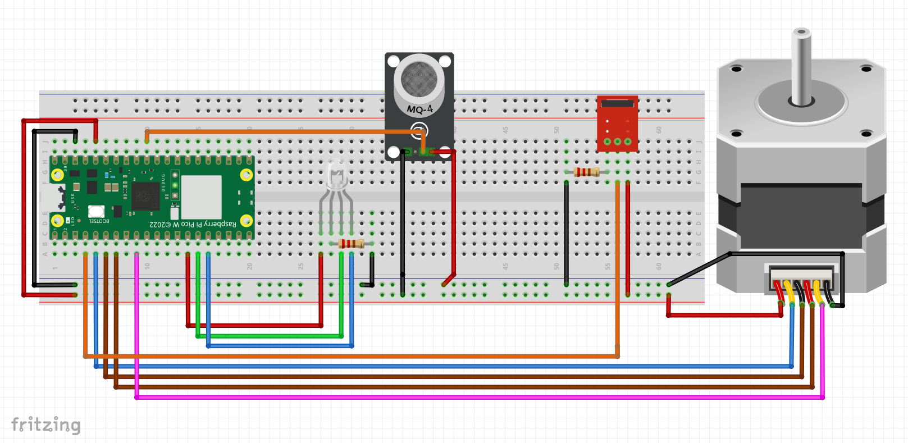

**Program codes:**

metin, ekran görüntüsü, yazı tipi içeren bir resim

Açıklama otomatik olarak oluşturuldu

metin, ekran görüntüsü, yazı tipi içeren bir resim

Açıklama otomatik olarak oluşturuldu

metin, ekran görüntüsü, yazı tipi içeren bir resim

Açıklama otomatik olarak oluşturuldu

metin, ekran görüntüsü, yazı tipi içeren bir resim

Açıklama otomatik olarak oluşturuldu

metin, ekran görüntüsü, yazı tipi içeren bir resim

Açıklama otomatik olarak oluşturuldu

metin, ekran görüntüsü, yazı tipi içeren bir resim

Açıklama otomatik olarak oluşturuldu

metin, ekran görüntüsü, yazı tipi, çizgi içeren bir resim

Açıklama otomatik olarak oluşturuldu

**Photo for your circuit (only 1 photo):**

